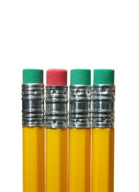
Melnyk/Scheffer/Vogel Suggested Supply List

Pictures are provided to clarify which materials are suggested and helpful with keeping your student organized and as germ free as possible. Product brands are entirely up to you. Please make sure all materials are labeled with first and last name in permanent black marker. If you are unable to supply these items, please let us know and we will do our best to assist you.
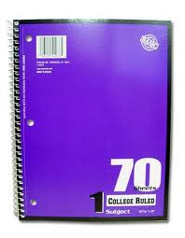
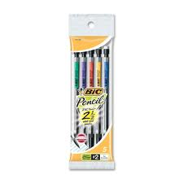
1. Mechanical pencils are the best! The sharpener
creates distractions. Remember to bring lead!
You might need a pencil pouch as well to keep all of
your materials with you during the day!
2. Spiral notebook - Needed for Science
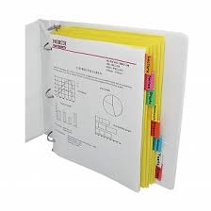
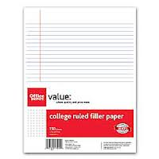
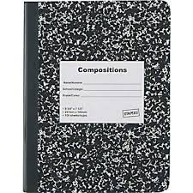
3. Loose leaf paper - 2 packs, 1 wide ruled for Reading
and Writing and 1 college ruled for Math

4. Composition Notebook 2, 1 for Writing
(Vogel only) and 1 for Soc.Stud.

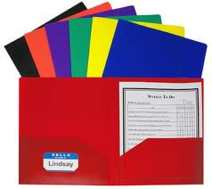
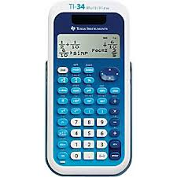
5. 3 ring binder with a 5 pack of dividers for Math
6. Calculator (basic scientific not a graphing calculator)
for Math and Sci.
7. 4, two pocket folders (a different color for each subject
-Reading, Writing, Sci., and S.S. Plastic folders will hold up
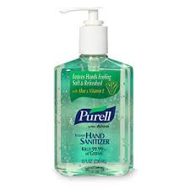
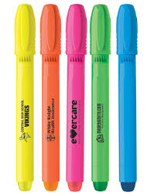
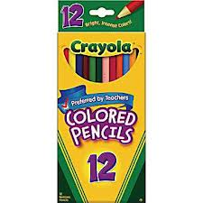
the entire year. The paper style typically lasts only a quarter.
8. Colored pencils for S.S.
9. Highlighter for all subjects
10. Tissues & Hand Sanitizer
Runny, snotty noses are still present in 6th grade. Please help
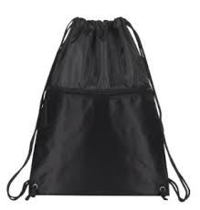
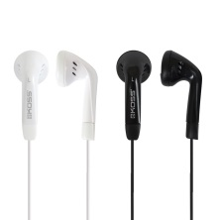
us to keep our colds under control.
11. Ear Buds/ Ear Phones * These can be purchased at Walgreens
for $4.00 and do not have to be expensive. You will need your own
pair of ear buds for individual computer use. Being that our classrooms
will be moving to a much more individualized experience with the
1 to 1 computer initiative, it is important that speakers on tech. devices
remain quiet so as not to disturb others.

12. For safety reasons as well as due to space issues, drawstring bags and backpacks are not permitted in the classroom. Students must carry their materials to and from class. Bags are to be kept in lockers.

